# Project Documentation Phase 3

Event Management & Ticketing System on Salesforce

## Phase 3: Data Modeling & Relationships

### 1. Introduction

In this phase, we design the data model of the Salesforce application to represent the event management process. A well-structured data model ensures scalability, consistency, and efficient reporting.

This phase involves working with **Standard Objects, Custom Objects, Fields, Record Types, Page Layouts, Compact Layouts, Schema Builder, Relationships, and Junction Objects**.

### 2. Standard & Custom Objects

**Standard Objects:** - **Account** → Represents sponsoring organizations or partners.  
- **Contact** → Represents attendees or staff contacts.  
- **Opportunity** → Can be used for sponsorship or paid ticket deals.  
- **Case** → Can track attendee support requests.

**Custom Objects (specific to project):**

- **Event__c** → Stores event details (Name, Date, Venue, Capacity, Organizer).

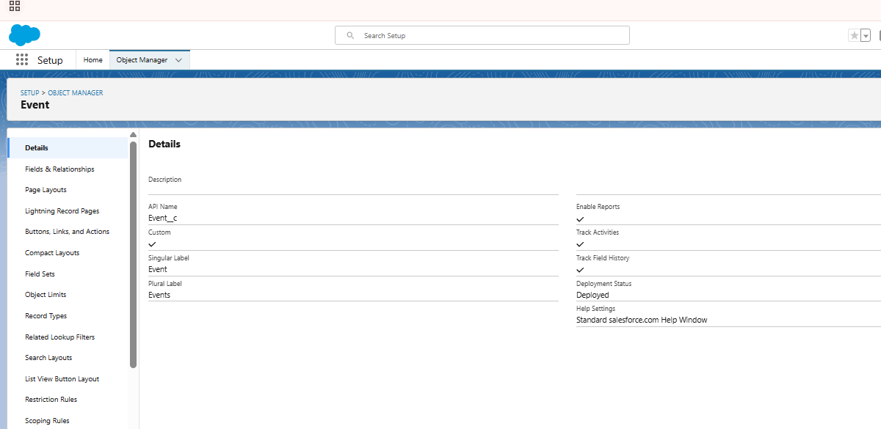  
- **Ticket__c** → Represents tickets issued for an event (Type, Price, QR Code, Status).

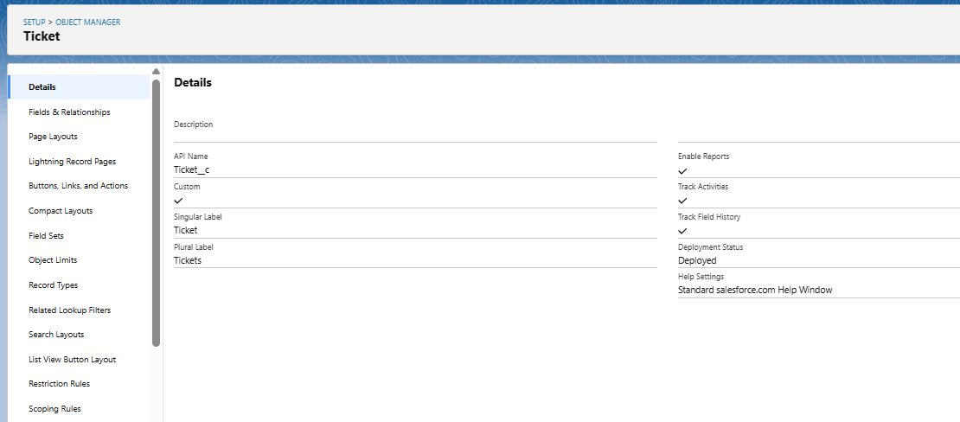  
-

**Attendee__c** → Represents participants (Name, Email, Phone, Check-in Status).

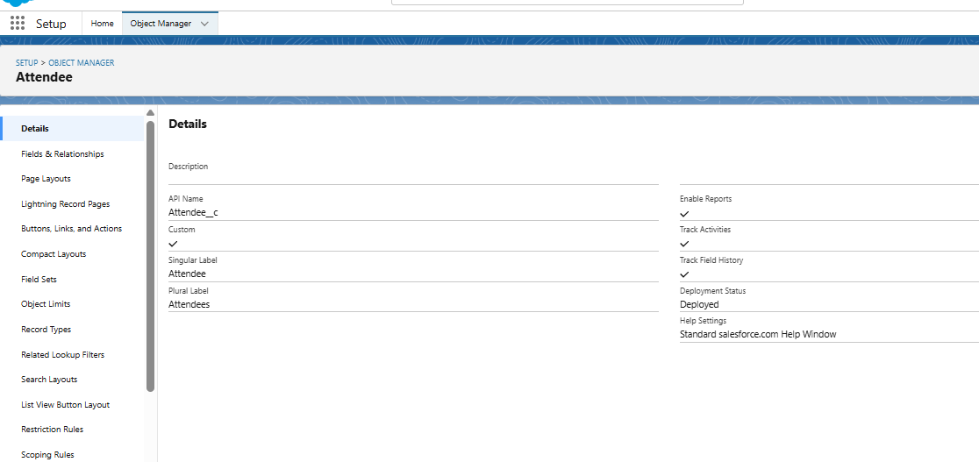

- **Feedback__c** → Captures post-event attendee feedback.

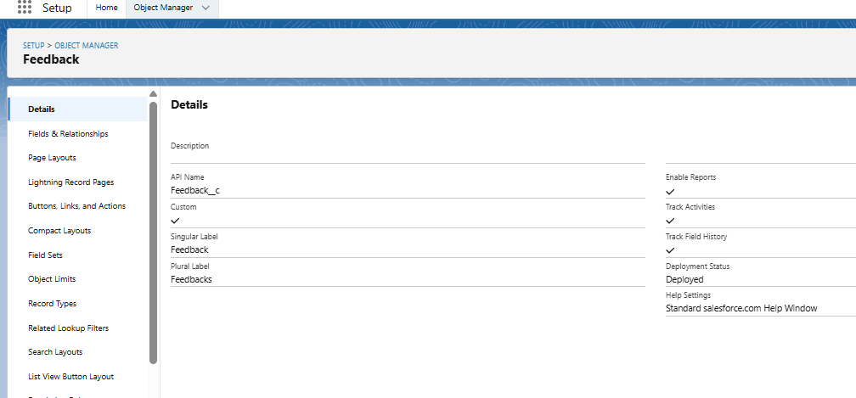  
- **EventAttendee__c (Junction Object)** → Links Attendees and Events (many-to-many relationship).

### 3. Fields

Each object has standard fields plus additional custom fields.

**Event__c Fields:** - Event Name (Text)  
- Event Date (Date)  
- Venue (Text)  
- Capacity (Number)  
- Organizer (Lookup → User)

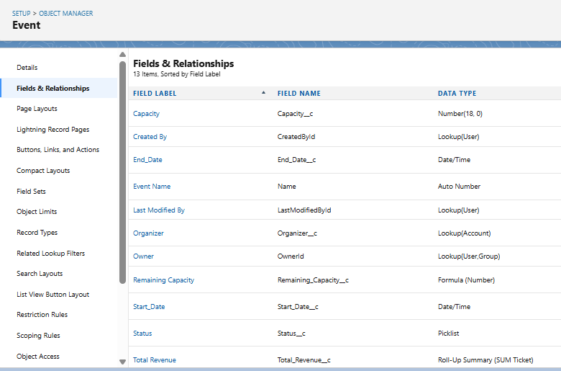

**Ticket__c Fields:** - Ticket Type (Picklist → VIP, Regular, Student)  
- Ticket Price (Currency)  
- QR Code (Text/External API link)  
- Status (Picklist → Issued, Scanned, Cancelled)  
- Related Event (Master-Detail → Event__c)

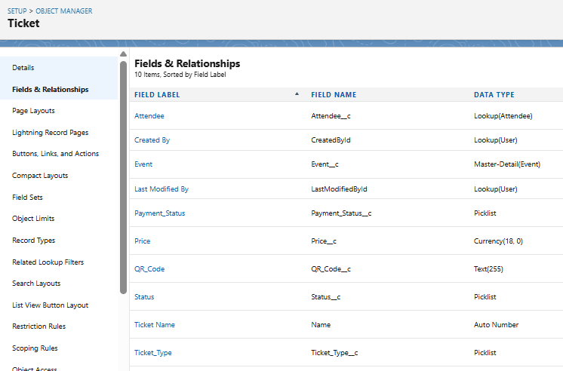

**Attendee__c Fields:** - Attendee Name (Text)  
- Email (Email)  
- Phone (Phone)  
- Registration Date (Date)  
- Check-in Status (Checkbox)  
- Ticket (Lookup → Ticket__c)

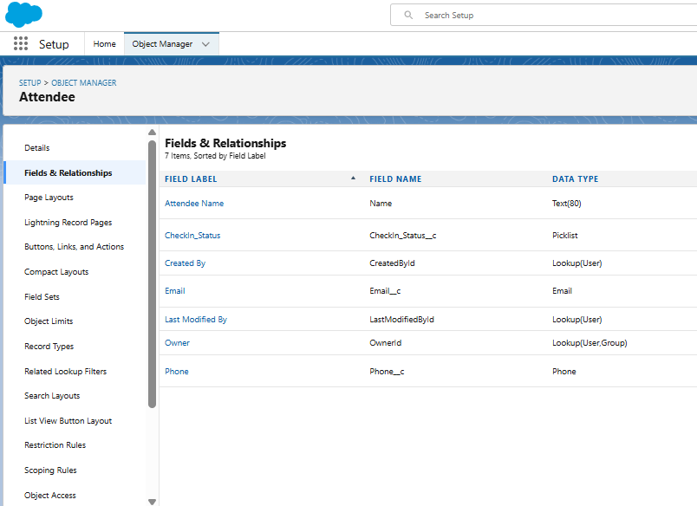

**Feedback__c Fields:** - Rating (Picklist: 1–5)  
- Comments (Long Text Area)  
- Related Event (Lookup → Event__c)  
- Related Attendee (Lookup → Attendee__c)

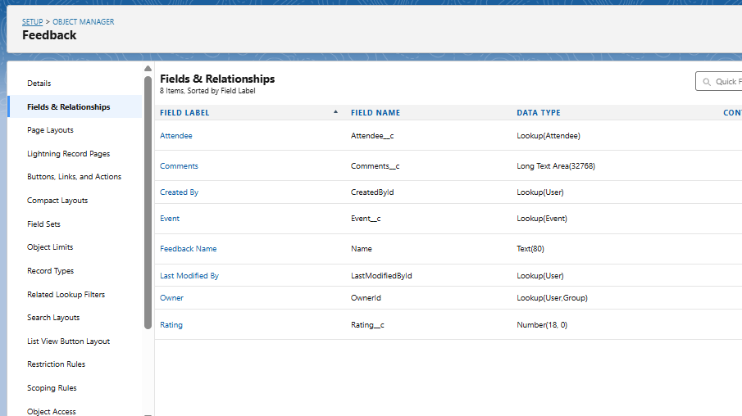

**EventAttendee__c (Junction Object):** - Event (Master-Detail → Event__c)  
- Attendee (Master-Detail → Attendee__c)  
- Registration Status (Picklist → Registered, Confirmed, Cancelled)

### 4. Record Types

Record Types allow different processes within the same object.

**Event__c Record Types:** - Conference  
- Workshop  
- Concert/Festival

**Ticket__c Record Types:** - VIP Ticket  
- Regular Ticket  
- Student Ticket

**Attendee__c Record Types:** - Individual Attendee  
- Corporate Attendee (linked to Account)

### 5. Page Layouts

**Event__c Layouts:** - Conference Layout → Includes Agenda, Speaker Details.  
- Workshop Layout → Includes Trainer, Materials.  
- Concert Layout → Includes Artist Line-up, Stage Details.

**Ticket__c Layouts:** - VIP Ticket Layout → Shows exclusive benefits.  
- Regular Ticket Layout → Shows standard seating details.

**Attendee__c Layouts:** - Individual Layout → Basic contact details.  
- Corporate Layout → Includes Company (Account Lookup).

### 6. Compact Layouts

**Event__c Compact Layout:** Event Name, Date, Venue, Capacity.

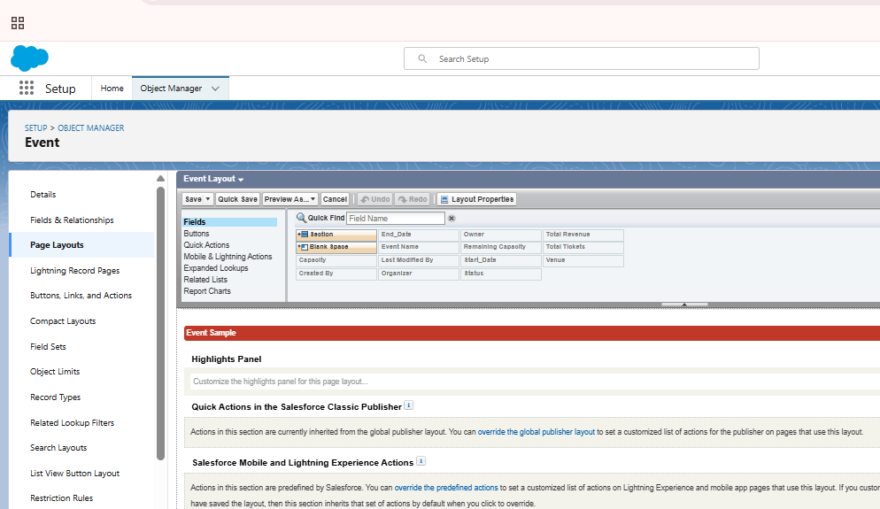

**Ticket__c Compact Layout:** Ticket Type, Price, Status.

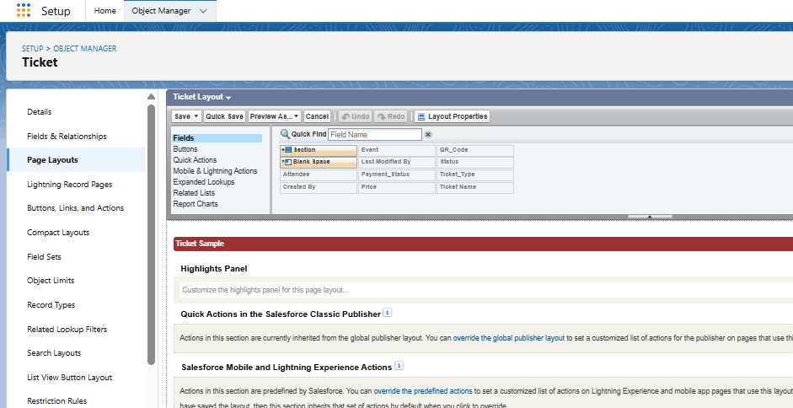

**Attendee__c Compact Layout:** Attendee Name, Email, Check-in Status.

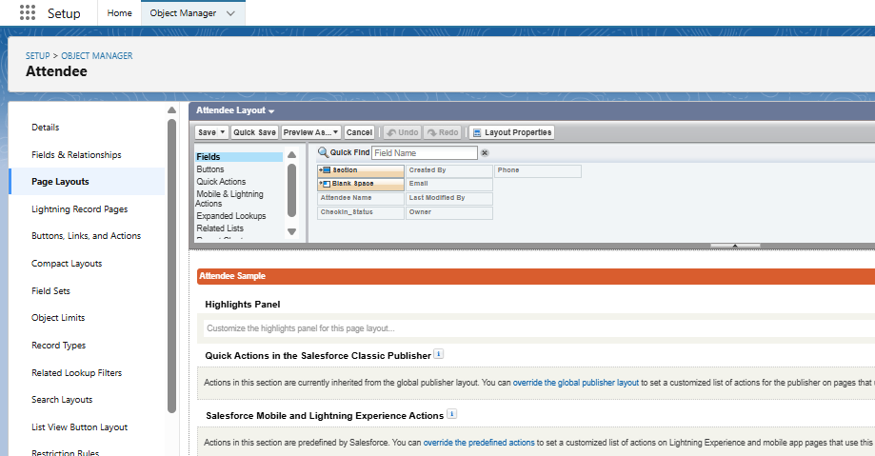

**Feedback__c Compact Layout:** Rating, Related Event, Related Attendee.

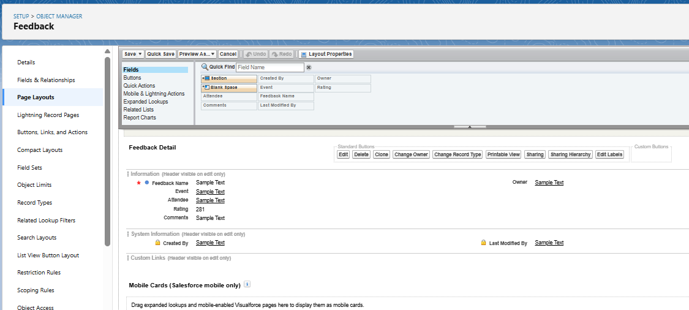

### 7. Schema Builder

Schema Builder will be used to: - Visualize relationships between **Event, Ticket, Attendee, Feedback, EventAttendee**.  
- Arrange objects to represent ERD (Entity Relationship Diagram).  
- Validate fields and relationships created.

### 8. Relationships

* **Event__c → Ticket__c:** Master-Detail (an Event can have many Tickets).
* **Event__c → EventAttendee__c:** Master-Detail.
* **Attendee__c → EventAttendee__c:** Master-Detail.
* **Attendee__c → Ticket__c:** Lookup (an attendee may hold a ticket).
* **Event__c → Feedback__c:** Lookup.
* **Attendee__c → Feedback__c:** Lookup.

### 9. Junction Objects

* **EventAttendee__c** is the junction object between Event and Attendee.
* Purpose: Manage many-to-many relationships (one event has many attendees, one attendee can attend many events).

### 10. External Objects

* **External_Payment__x** → Connects Salesforce to payment gateway (Stripe/PayPal) for ticket purchases.
* **External_Survey__x** → Connects Salesforce to external survey tool (Google Forms/SurveyMonkey) for feedback.

### 11. Documentation Deliverables

* ERD Diagram (Event, Ticket, Attendee, Feedback, EventAttendee).
* Custom Object & Field Tables (Name, API Name, Type, Description).
* Record Type & Layout Mapping.
* Junction Object Mapping.
* Screenshots: Schema Builder, Page Layouts, Compact Layouts.

### 12. Benefits of This Phase

* Provides a clear and scalable data structure.
* Enables automation of registrations, reminders, and check-ins.
* Supports advanced reporting & dashboards.
* Prepares model for integration with payment & survey systems.

✅ **Phase 3 Deliverable:** By the end of Phase 3, we have: - Defined objects, fields, and relationships.  
- Mapped record types, layouts, and compact layouts.  
- Designed ERD using Schema Builder.  
- Established junction objects for many-to-many relationships.  
This forms the foundation for **Phase 4: Process Automation (Admin)**.